

Aptech Computer Education

Shahrah-e-Faisal Center

1st Semester e-Project

MVC Online SMS

Group Members

•Student:1334899 Umar Abdul Wahid

•Student:1333600 Muhammad Maaz

•Student:1333930 Muhammad Ammar

•Student:1333918 Ayaan Faisal



*This is to certify that this project entitled*

***HTML***

*Submitted*

*in partial fulfillment of the*

***ACCP***

***PR2-202108B***

*Done*

*by following candidates*

.

•Student:1334899

Umar Abdul Wahid

•Student:1333600 Muhammad Maaz

•Student:1333930 Muhammad Ammar

•Student:1333918 Ayaan Faisal



**Table of Contents**

*Certificate……….……….……….……………………………………….02*

*Introduction………...………………...……………………………………05*

*Functional Requirement…………………………………………………07*

*Objectives of the project …………………………............................08*

*Problem Statements……………………………………………………...09*

*Deliverables………………………………………………………………….11*

*Hardware/ Software Requirements…………………………………...12*

*Screenshots………………………………………………………………….13*

*Summary………………………………………………………………….23*

*Task Sheet………………………………………………………………….24*



**Acknowledgement**

***W***

*e are Thankful to*

***ALMIGHTY***

***ALLAH***

*that by HIS*

*Grace,*

*we have been*

*successful. We*

*are presenting our project*

*(*

*E*

*-*

*Project)*

*we have*

*tried our best*

*To*

*take all relevant and necessary topics into our consideration*

*So*

*that this project may*

*become comprehensive.*

***T***

*his is our*

*First*

*Semester*

*E*

*-*

*Project. We have strived for a better*

*Outlook to come. This project has been developed*

*by using*

*HTML*

*We find it easy to utilize the editor.*

***W***

*e would like to thank*

***Sir***

***Faizan***

*for his guidance and for giving*

*Us*

*t*

*ime from their busy schedule.*

***W***

*e also express our sincere gratitude to E*

*-*

*Project team from Aptech*

*Head Office, for their valuable guidance and support for the completion*

*of this*

*Project*

*.*

***W***

*e earnestly hope that this project will provide all the necessary*

*Information required*

*by the user to fulfill his/her inspiration.*

*However, suggestion and*

*Feedbacks*

*for improvements will be thankfully*

*Welcomed*

*& acknowledged*

**Thank You.**

**INTRODUCTION**

*The thirst for learning, upgrading technical skills and applying the concepts in real life environment at a fast pace is what the industry demands from IT professionals today. However busy work schedules, far-flung locations, and unavailability of convenient time-slots pose as major barriers when it comes to applying the concepts into realism. And hence the need to look out for alternative means of implementation in the form of laddered approach.*

*The above truly pose as constraints especially for our students too! With their busy schedules, it is indeed difficult for our students to keep up with the genuine and constant need for integrated application which can be seen live especially so in the field of IT education where technology can change on the spur of a moment. Well, technology does come to our rescue at such times!!*

*Keeping the above in mind and in tune with our constant endeavor to use Technology in our training model, we at Aptech have thought of revolutionizing the way our students learn and implement the concepts using tools themselves by providing a live and synchronous iProject learning environment!*

***So, what is this eProject?***

*eProject is a step by step learning environment that closely simulates the classroom and Lab based learning environment into actual implementation. It is a project implementation at your fingertips!! An electronic, live juncture on the machine that allows you to*

* *Practice step by step i.e. laddered approach. o Build a larger more robust application. o Usage of certain utilities in applications designed by user. o Single program to unified code leading to a complete application. o Learn implementation of concepts in a phased manner. o Enhance skills and add value. o Work on real life projects. o Give a real life scenario and help to create applications more complicated and useful.*
* *Mentoring through email support.*

The students at the centre are expected to complete this eProject and send complete project along with the documentation to eProjects Team

Looking forward to a positive response from your end!!

**Objectives of the Project**

The Objective of this program is to give a sample project to work on real life projects. These applications help you build a larger more robust application.

The objective is not to teach you HTML/JavaScript/Dreamweaver but to provide you with a real life scenario and help you create basic applications using the tools.

You can revise the chapters before you start with the project.

This project is meant for students who have completed the module of ***Dreamweaver***. These programs should be done in the Lab sessions with assistance of the faculty if required.

It is very essential that a student has a clear understanding of the subject. Students should go through the project and solve the assignments as per requirements given.

Kindly get back to eProjects Team in case of any doubts regarding the application or its objectives.

**Problem Statements**

Amazing Bridges website will present the information about the various famous bridges throughout the world. The information behind this creation must be added. The information of amazing bridges can be categorized based on zone wise (Longest, Tallest, Highest, Oldest etc.).

**Requirement Specification:**

The Web site is to be created based on the following requirements

1. The Home Page should be created making use of Sections with a suitable logo, the header section can be added which will show images of famous bridges.
2. The site must contain the links to navigate through any category for the information.
3. Links of monuments can be categorized by zone wise like (Longest, Tallest, Highest, Oldest etc.) apart from country wise link can be added.
4. History and information of the bridges can be added along with the images.
5. Gallery section can be added for viewing different images.
6. Feedback must be allowed to enter by the viewer
7. Site map, Gallery, about us, Queries link, Contact us link must be added.
8. The complete historic reason and its description must be allowed to get download as pdf or doc file.
9. The advertise section of bus, flights can be included for reaching the places.
10. the sales services for that company using the in-bound or out-bound services, then these details are to be maintained, etc.) are to be maintained.
11. Based on the charges levied for a service, the total charges for the clients are to be calculated based on the services that the client prefers.
12. The details of the payments as received by the client are to be maintained.
13. The reports for the late payments, payments, clients, employees based on the services, for a particular duration are to be generated

**Hardware / Software Requirement**

**Hardware**

* A minimum computer system that will help you access all the tools in the courses is a Pentium 166 or better
* 64 Megabytes of RAM or better

**Software**

* Notepad/HTML editor
* Dreamweaver
* IE 5.0/ Netscape 6.0

*SCREEN SHOTS*

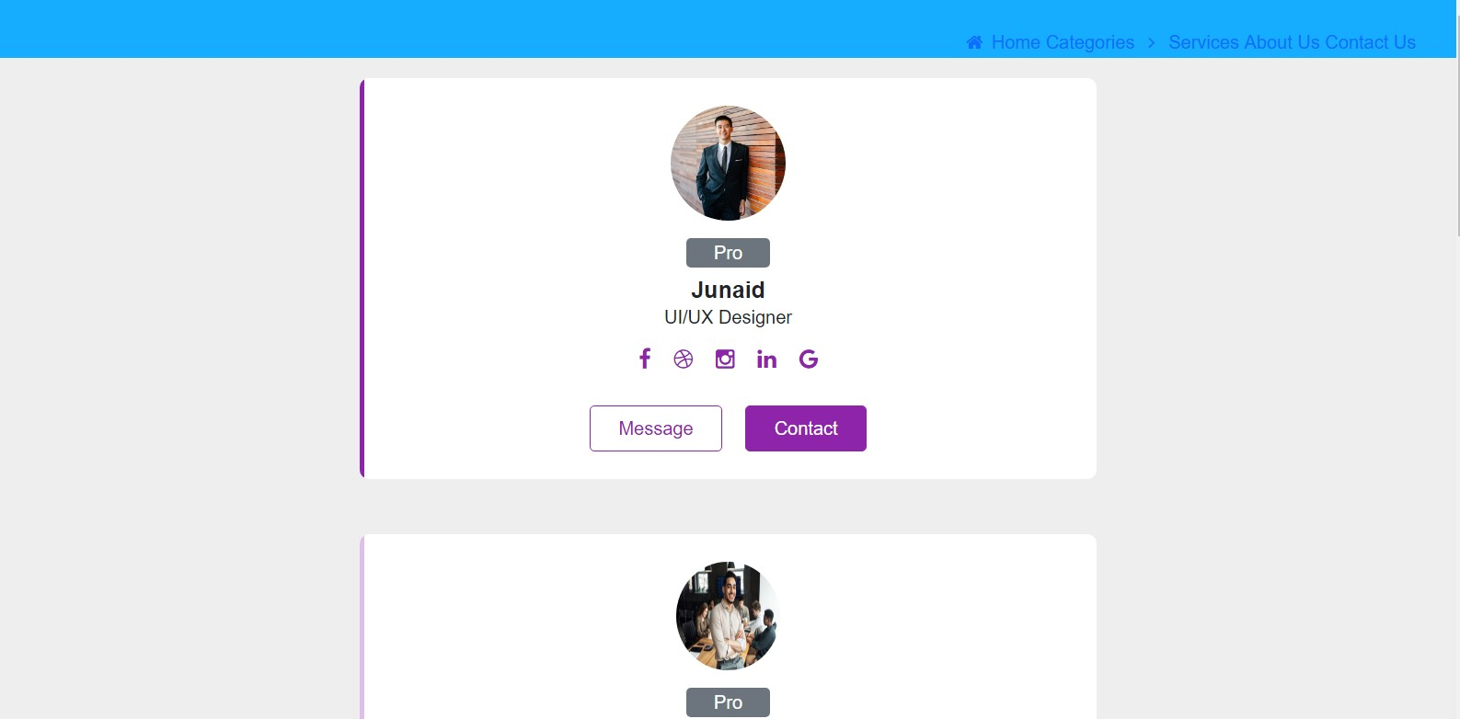

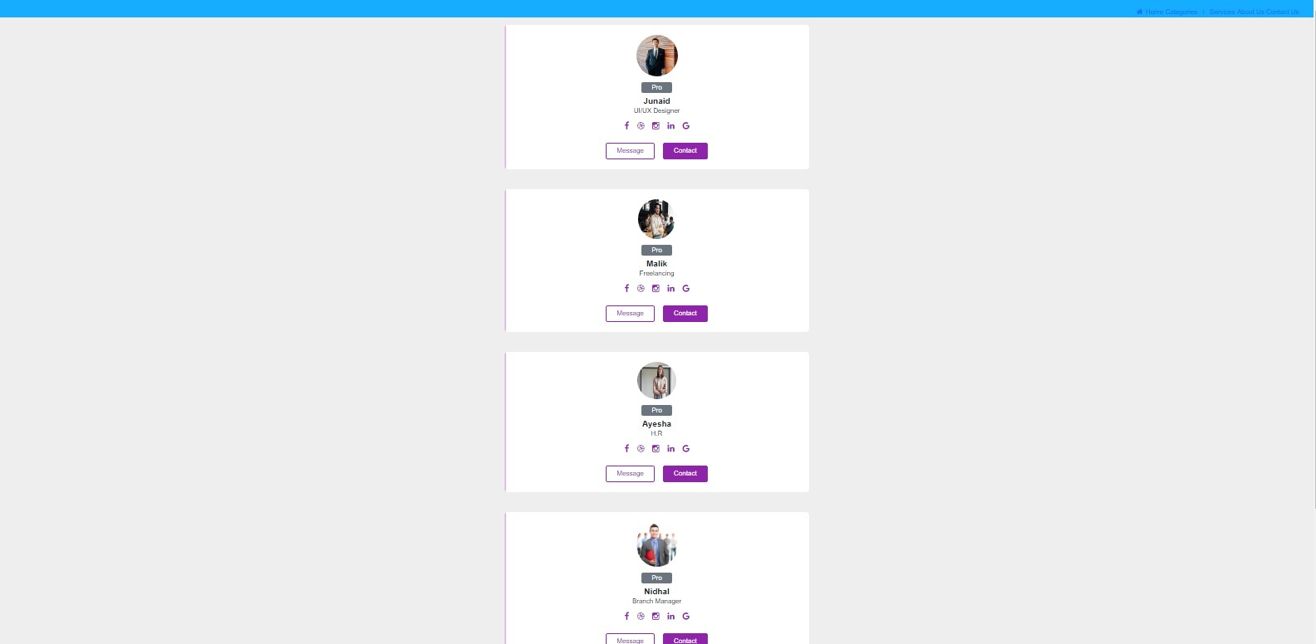

*Codinh S,S*

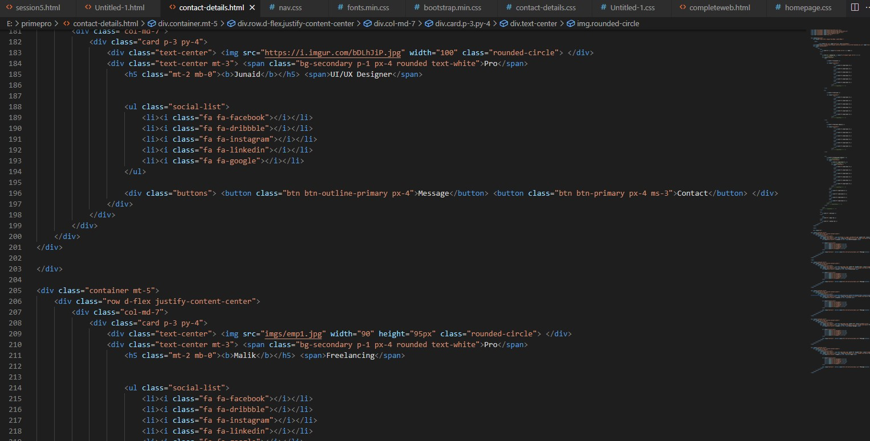

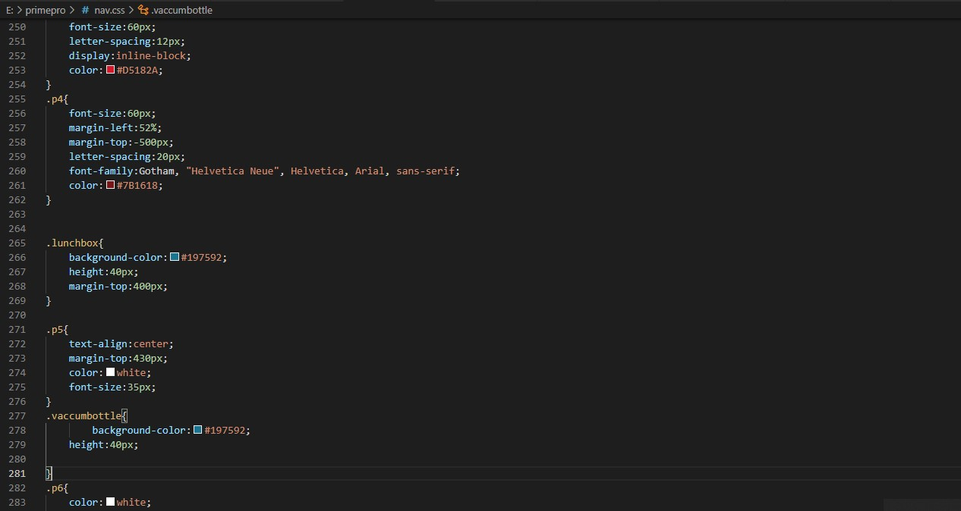



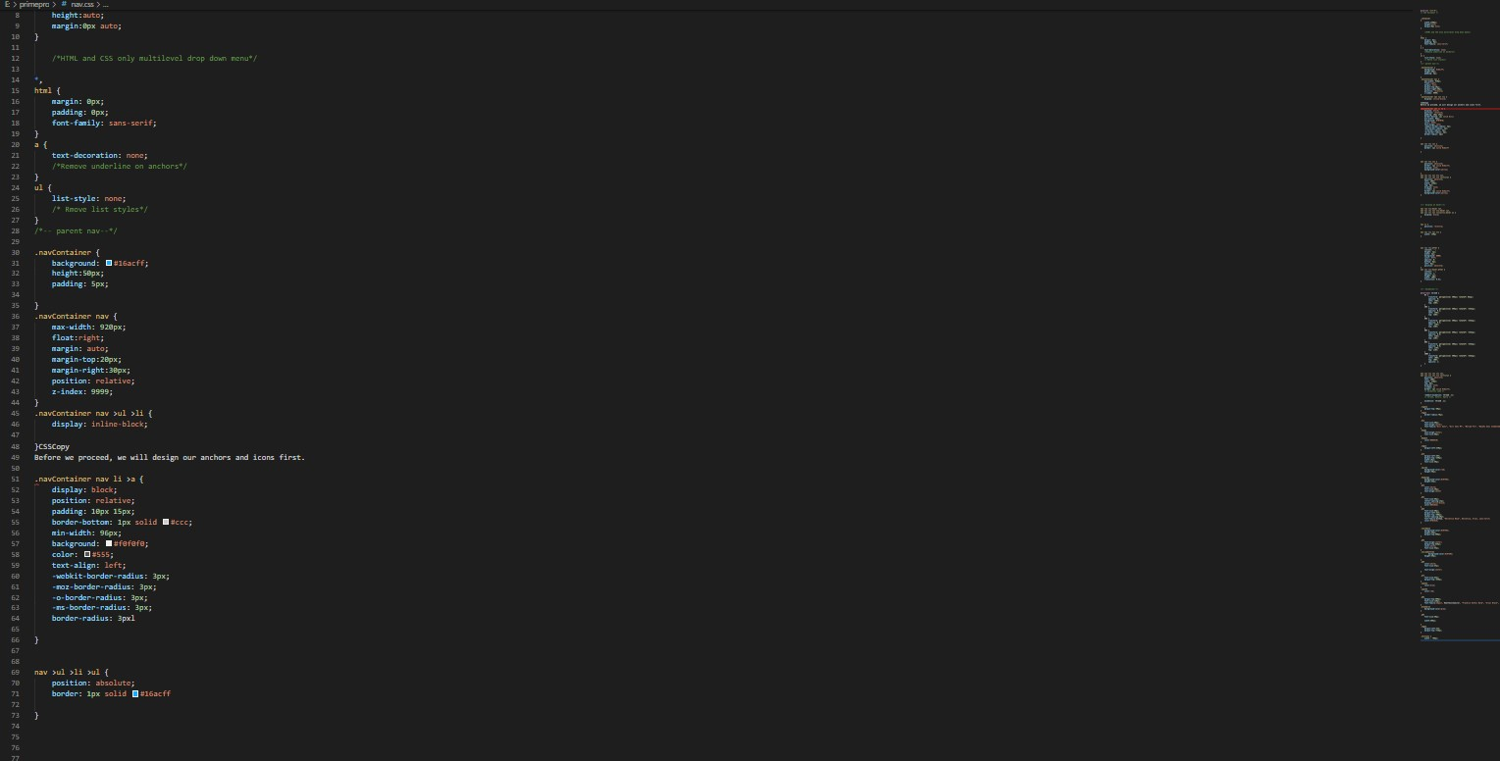

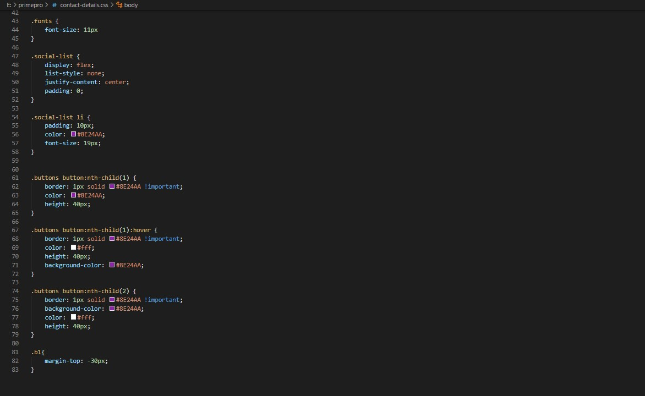

**CODING DASHBOARD**

**SUMMARY**

* *Managing an Tele-marketing marketing project is no easy task. Regardless of the countless number of projects launches you have under your belt, every day is a learning opportunity. The one thing that should remain consistent from one project to the next is your utmost attention to detail. The cliché “Plan, Plan, Plan” is a simple summary of what it takes to be successful. Let’s discuss this more in depth.*

* *The database should contain the details of the services, department details, employee details, client details, the details of the services that are preferred by the clients, the product details of the clients.*

* *One should be able to maintain the details of the charges levied for each type of service.*

* *One should be able to insert, update, delete and search and retrieve the records of the clients.*

* *The advanced search option is to be implemented so as to fetch and retrieve the records.*

*While this plan may seem counterintuitive at first glance, this can be the difference between success and failure. Think through every way the call can go, especially the worst, so you can prepare the team to handle it. Whether it’s the one-off objections or additional questions that will inevitably come up on the call, the more of these things that you can identify and resolve before launch the more likely you are to succeed.*

*TASK SHEET*

|  |  |  |  |  |
| --- | --- | --- | --- | --- |
| Project Ref. No. | | Project Title | Date of Preparation of Activity Plan | |
| S.No. | **Task** | **EXCEL ON SERVICE** | **Actual Day** | **Status** |
| 1 | **Analysis** | **8** | **OK** |
| 2 | **Design** | **15** | **OK** |
| 3 | **Development** | **21** | **OK** |
| 4 | **Testing** | **25** | **OK** |
| 5 | **Documentation** | **28** | ***OK*** |